**Name :kareem Mostafa Mohmmed Abdul Samad**

**B.N : 1084**

**Section : 27**

**Date : 7/5/2025**

**Topic : programming languages .**

**Application Brief :**

A programming language is a vocabulary and set of grammatical rules for instructing a [computer](https://www.webopedia.com/TERM/C/computer.html) or computing device to perform specific tasks. The term programming language usually refers to [high-level languages](https://www.webopedia.com/TERM/H/high_level_language.html), such as [BASIC](https://www.webopedia.com/TERM/B/BASIC.html), [C](https://www.webopedia.com/TERM/C/C.html), [C++](https://www.webopedia.com/TERM/C/C_plus_plus.html), [COBOL](https://www.webopedia.com/TERM/C/COBOL.html), [Java](https://www.webopedia.com/TERM/J/Java.html), [FORTRAN](https://www.webopedia.com/TERM/F/FORTRAN.html), [Ada](https://www.webopedia.com/TERM/A/Ada.html), and [Pascal](https://www.webopedia.com/TERM/P/Pascal.html).

Each programming language has a unique set of keywords (words that it understands) and a special [syntax](https://www.webopedia.com/TERM/S/syntax.html) for organizing program [instructions](https://www.webopedia.com/TERM/I/instruction.html).

A programming language must be straightforward, simple to learn and utilize, have great meaningfulness and human conspicuous. Abstraction is a must-have Characteristics for a programming language in which capacity to characterize the mind boggling structure and afterward its level of ease of use comes.

. The segment of the language that a PC can comprehend is known as a“binary.” Translating programming language into binary is known as “compiling

**High-Level Programming Languages**

High-level programming languages, while simple compared to human languages, are more complex than the languages the computer actually understands, called [machine languages](https://www.webopedia.com/TERM/M/machine_language.html). Each different type of [CPU](https://www.webopedia.com/TERM/C/CPU.html) has its own unique machine language.

Lying between machine languages and high-level languages are languages called [assembly languages](https://www.webopedia.com/TERM/A/assembly_language.html). Assembly languages are similar to machine languages, but they are much easier to program in because they allow a [programmer](https://www.webopedia.com/TERM/P/programmer.html) to substitute [names](https://www.webopedia.com/TERM/N/name.html) for numbers. Machine languages consist of numbers only.

Lying above high-level languages are languages called [fourth-generation languages](https://www.webopedia.com/TERM/F/fourth_generation_language.html) (usually abbreviated 4GL). 4GLs are far removed from machine languages and represent the class of computer languages closest to human languages.

**The Top Programming Languages**

According to IEEE Spectrum's interactive ranking, Python is the top programming language of 2017, followed by C, Java and C++. Of course, the choice of which language to use depends on the type of computer the program is to [run](https://www.webopedia.com/TERM/R/run.html) on, what sort of program it is, and the expertise of the programmer.

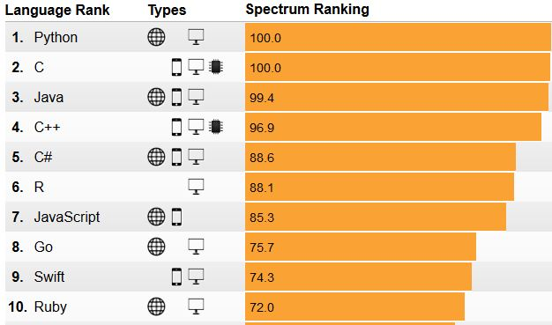

**Screenshots :**

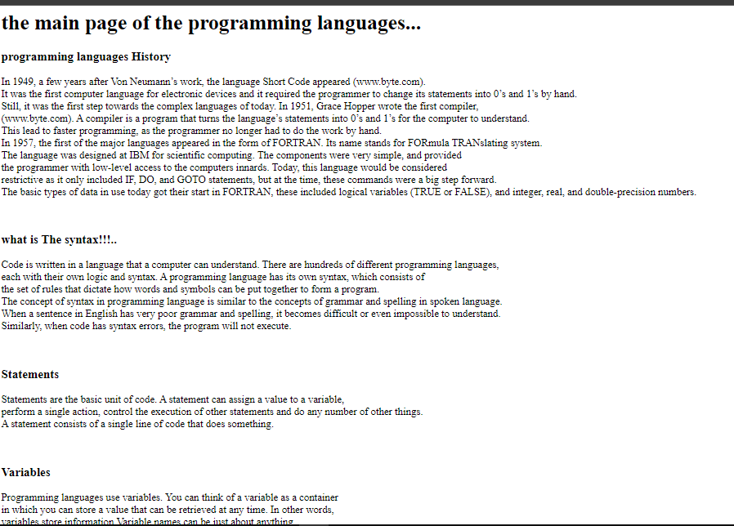

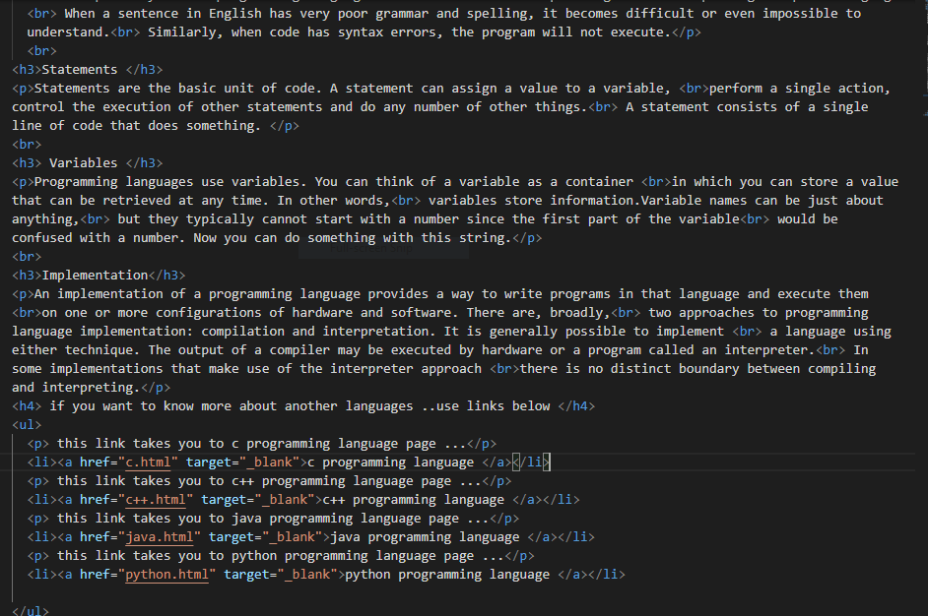

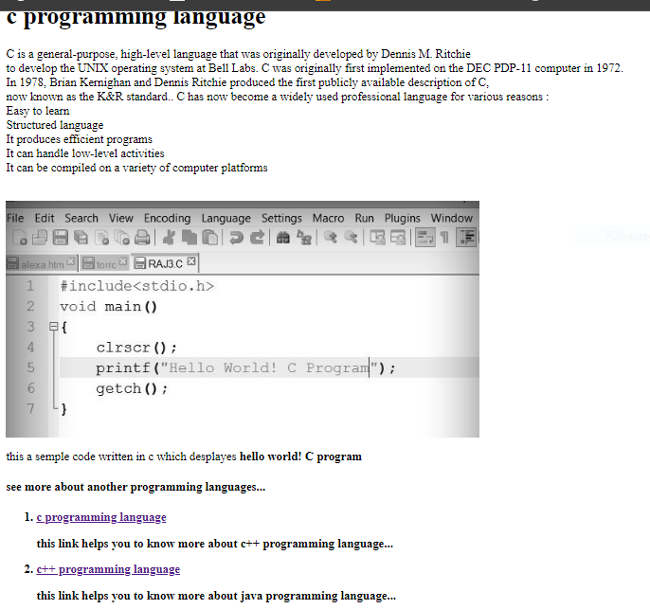

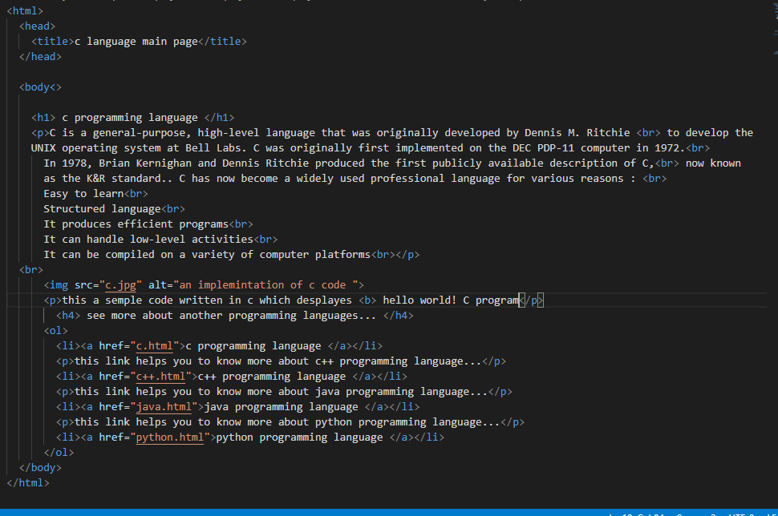

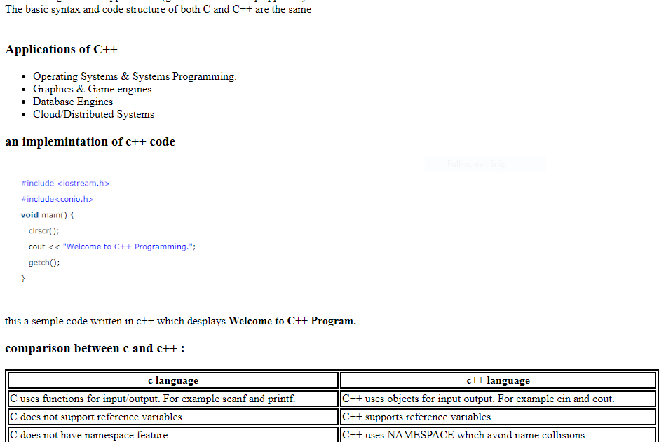

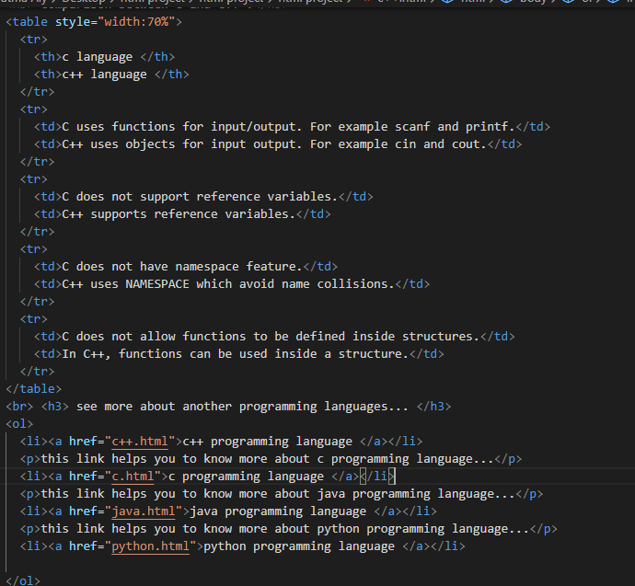

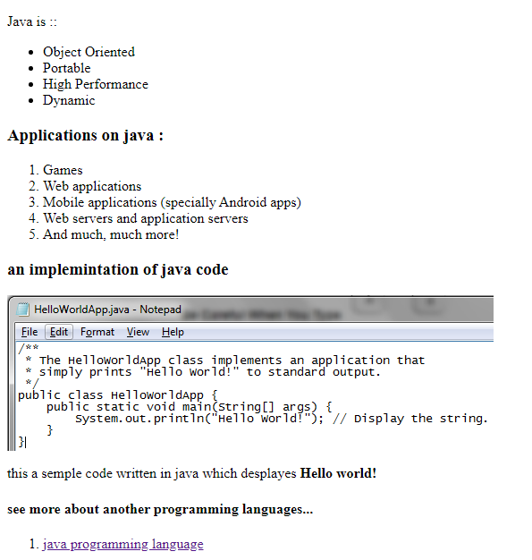

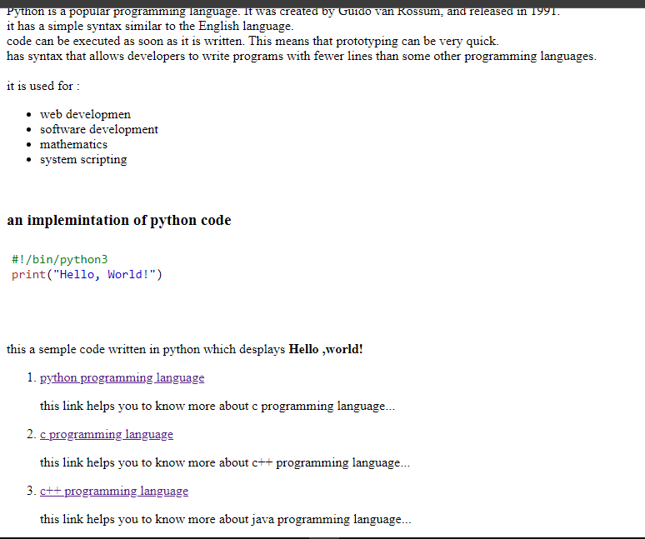

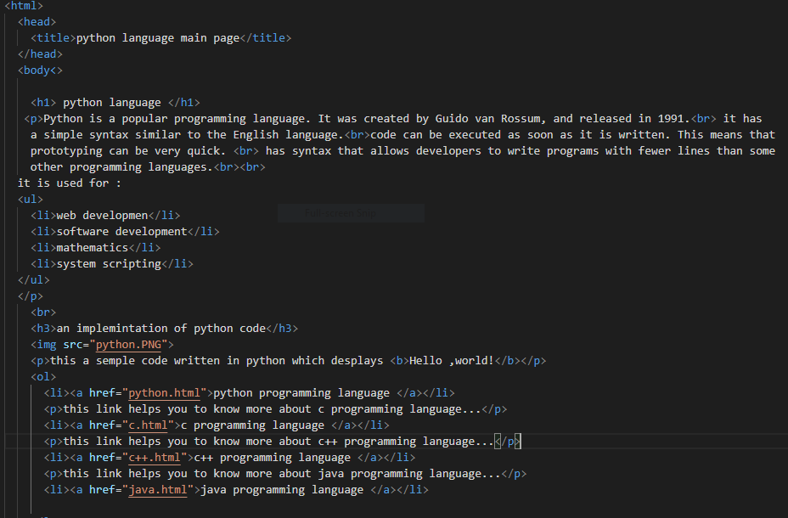

<https://www.w3schools.com/python/python_intro.asp>

<https://www.geeksforgeeks.org/introduction-to-c-programming-language/>

<https://www.webopedia.com/TERM/P/programming_language.html#:~:text=A%20programming%20language%20is%20a,FORTRAN%2C%20Ada%2C%20and%20Pascal.>